Above and Below Wave End

Given the Simple Diffusion (6e-6) 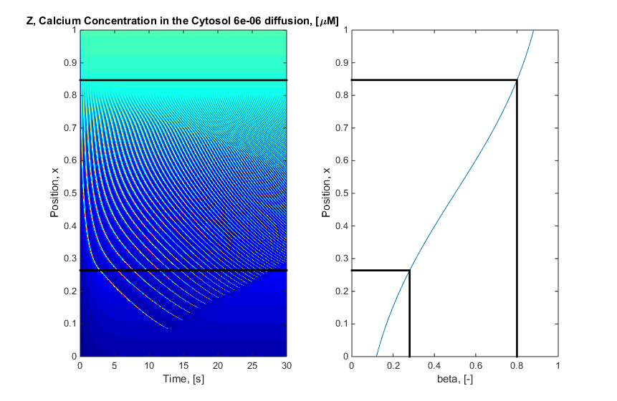

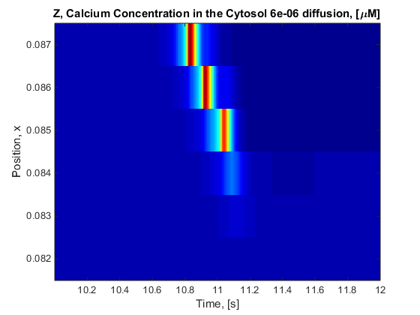

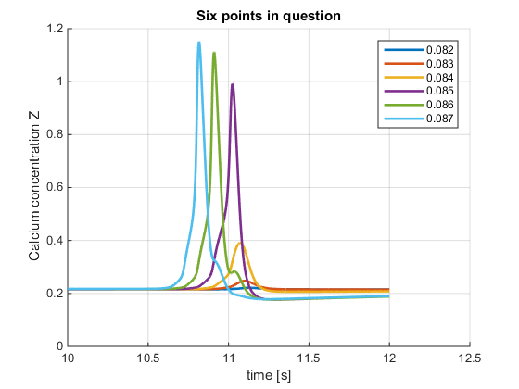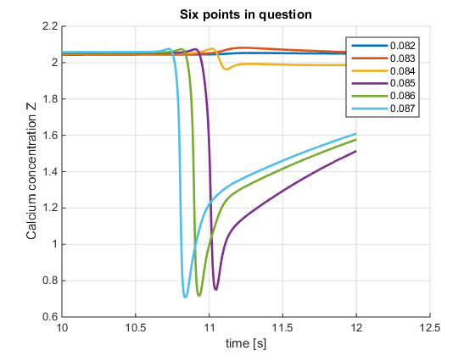

Y

There are multiple components to consider here which stem from the original equation:

$$\frac{dC}{dt}=D\frac{d^{2}C}{dx^{2}}+v_{0}+v_{1}β-v_{2}+v_{3}+k_{f}Y-kC$$

Where

$$v_{2}=V_{m2}\frac{C^{n}}{K_{2}^{n}+C^{n}} and v_{3}= V_{m3}\frac{Y^{m}}{K_{R}^{m}+Y^{m}}∙\frac{C^{p}}{K_{A}^{p}+C^{p}}$$

First of all it is easy to determine which components are already predictable, ie $v_{0}$, $v_{1}β$, $k_{f}Y$ and $kC$

$$v_{0}=1 v_{1}=7.3 ∴v_{0}+v_{1}β=\left\{1…7.3\right\}$$

Given the graphs above and that $k_{f}=1$ and $k=10$

$k_{f}Y=Y kC=\left\{0…10.2\right\}$ Instead

The components which will be considered are:

|  |  |  |  |
| --- | --- | --- | --- |
| Number | 1 | 2 | 3 |
| Component |  |  |  |

# V2 and V3

For V2 it is clear why it follow the graph similar to that of Z (see book)

For V3 again it roughly is the same graphs as that of Z. This is because as you go into the wave Y drops and Z rises. This means in the V3 equation the second half is dominant and that part is determined by Z

# Diffusion

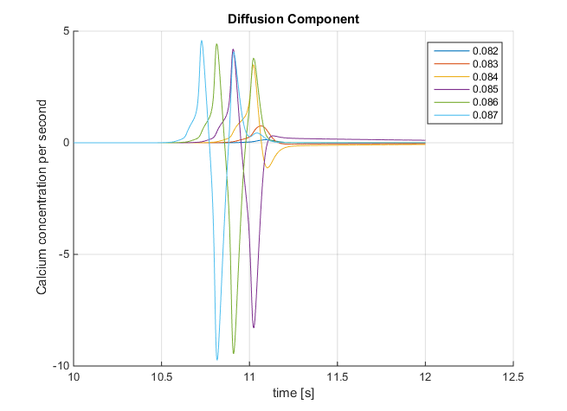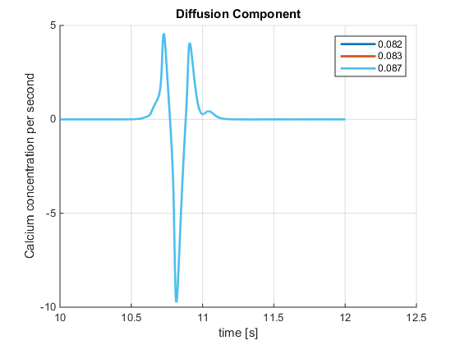

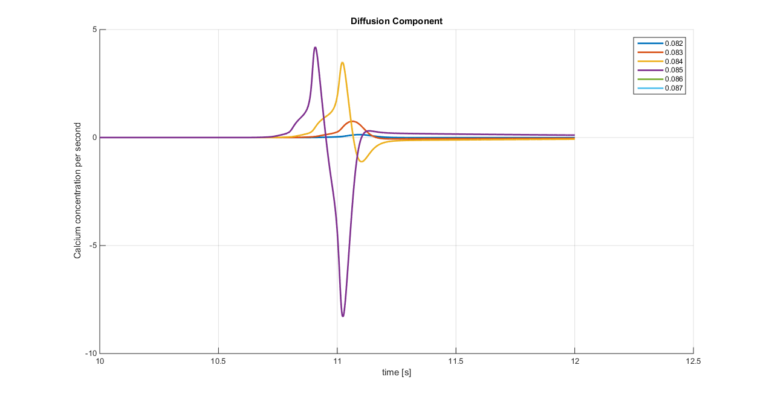

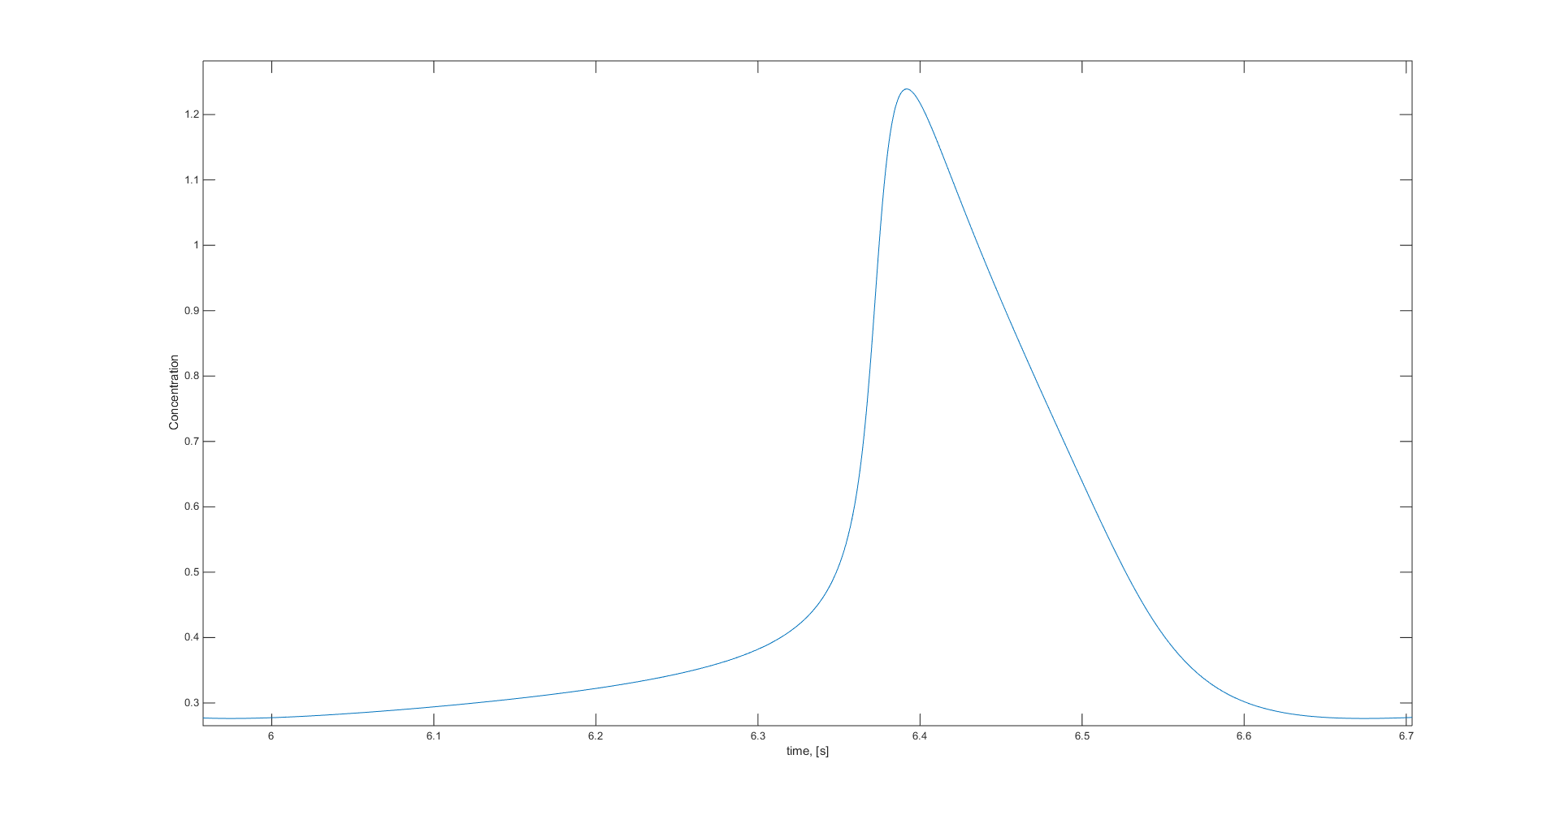

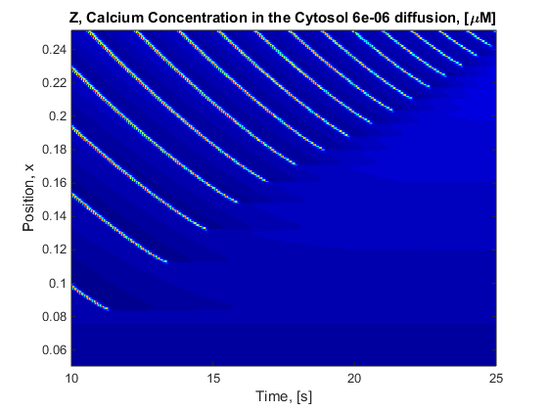

**14**

**16**

**15**

**12**

**13**

**11**

**10**

**9**

**8**

**7**

**6**

**5**

**4**

**3**

**2**

**1**